1. Remove duplicate column:

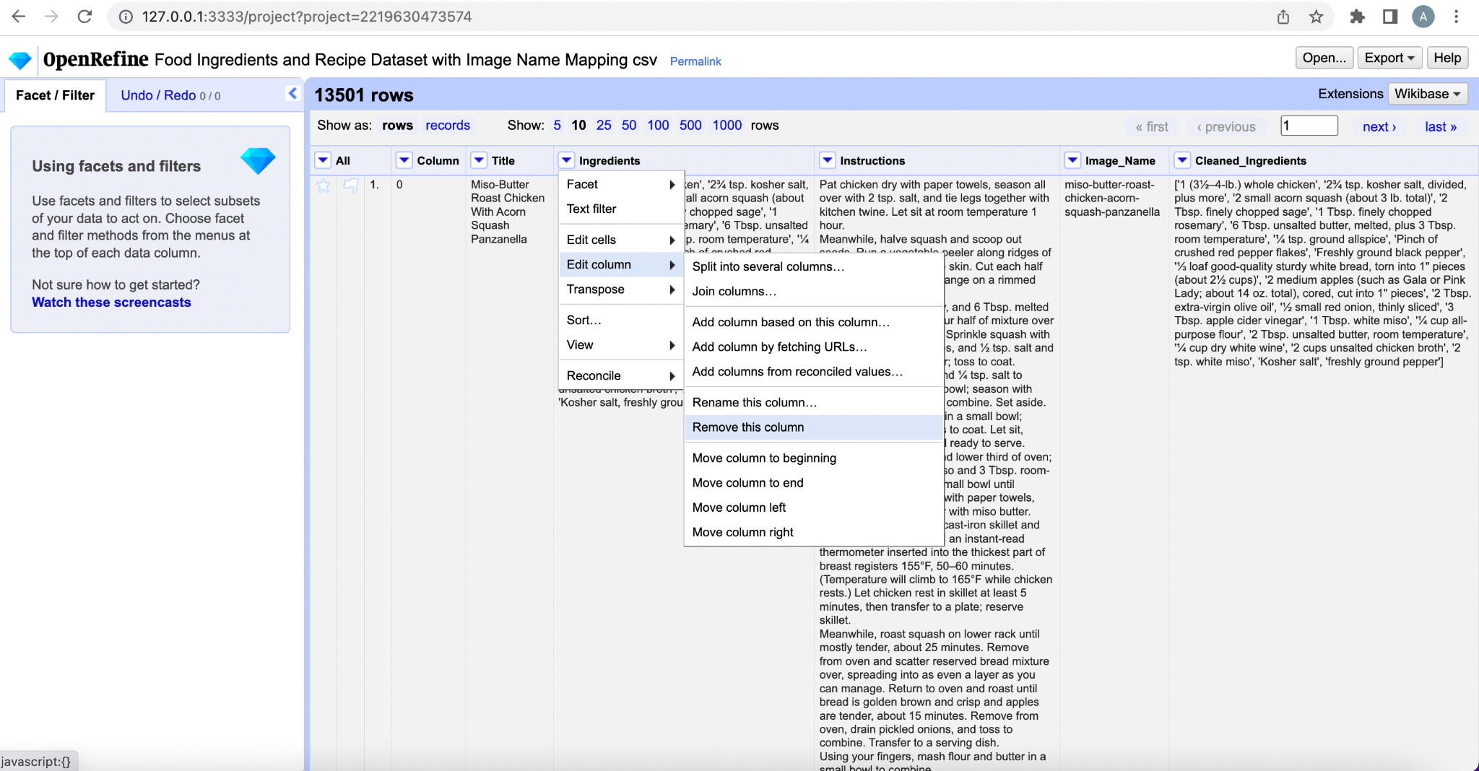

1. Remove unwanted column:

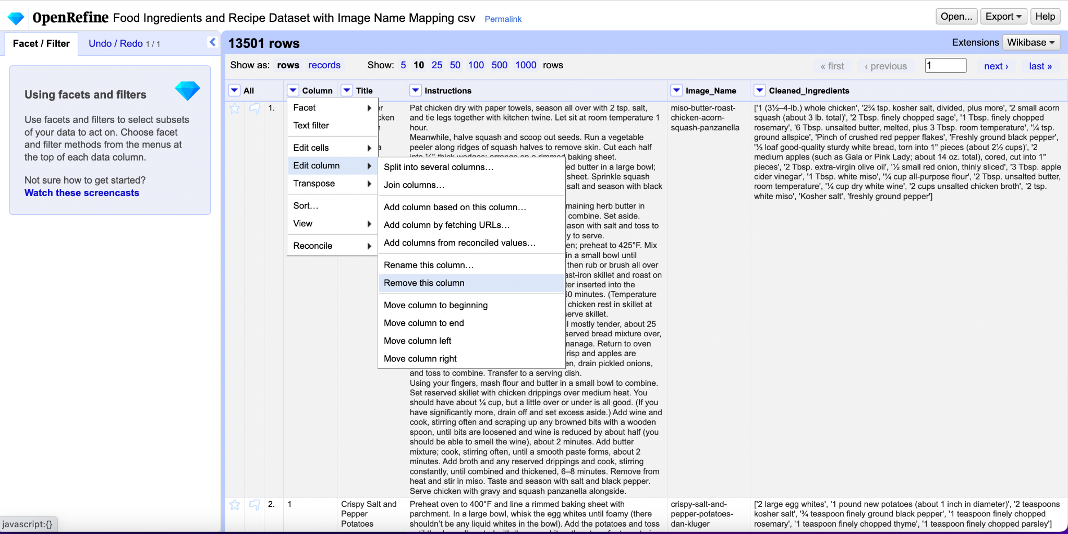

1. Remove records with no recipe name:

